**OUTPUT SCREENSHOTS**

**HOME PAGE:**

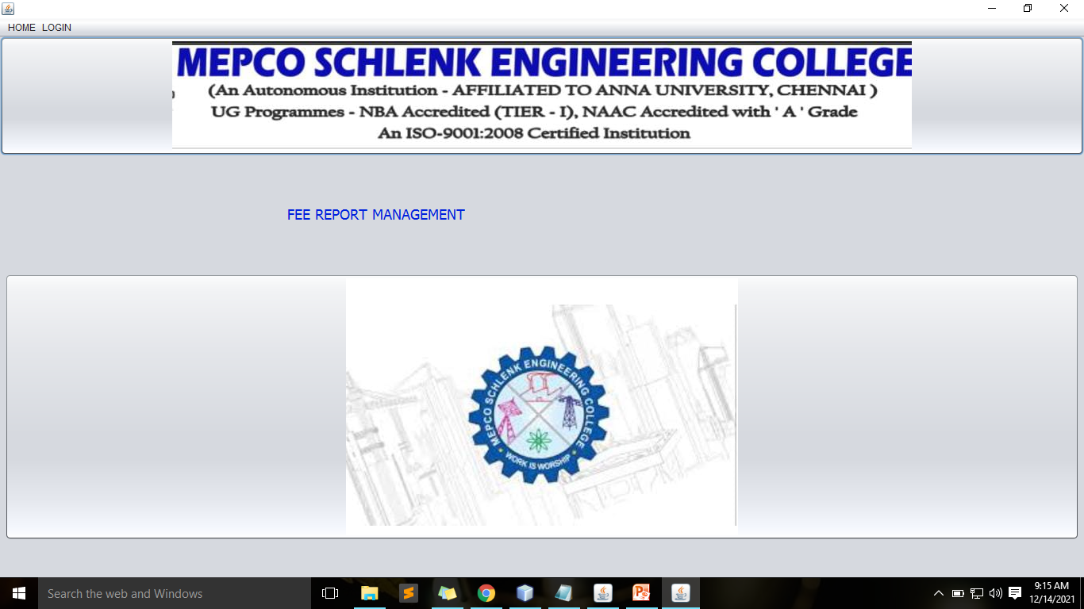

**LOGIN PAGE:**

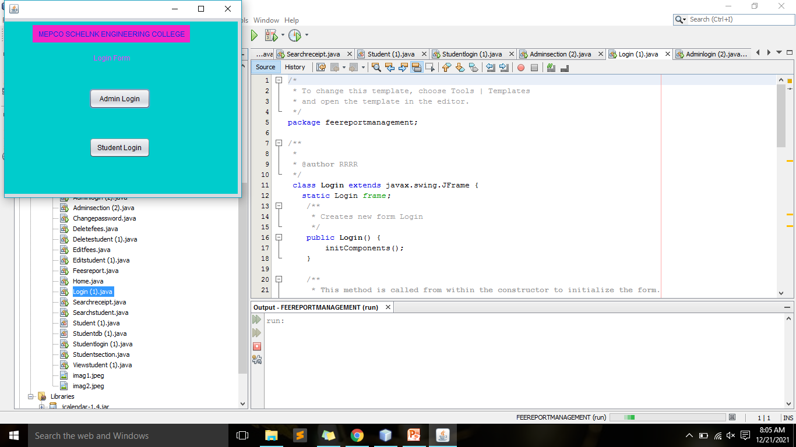

**ADMIN LOGIN**

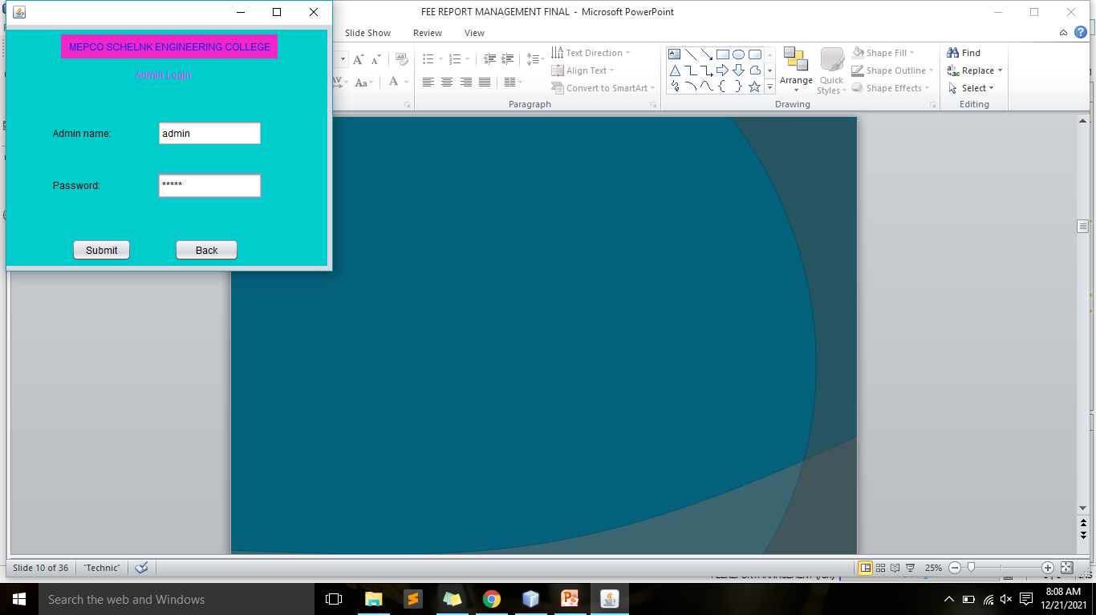

**ADMIN SECTION:**

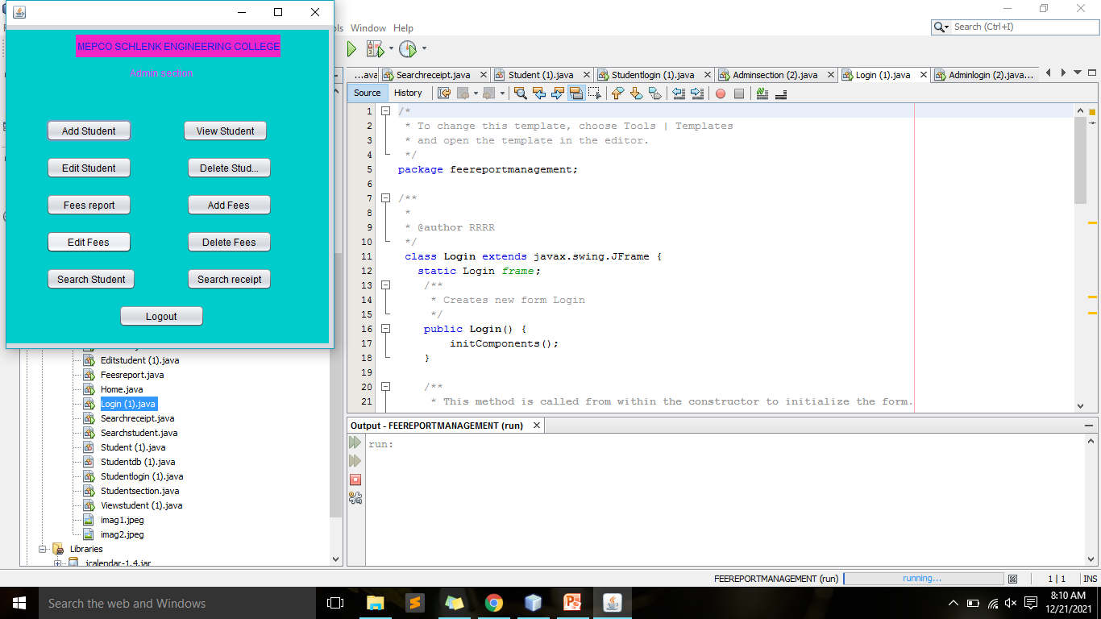

**ENTERING INVALID EMAIL ID**

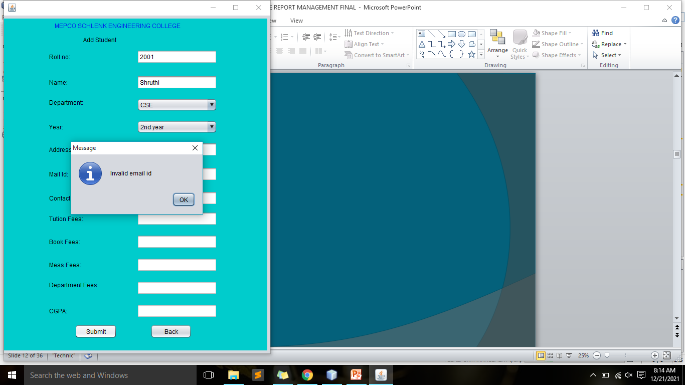

**ENTERING INVALID CONTACT NO:**

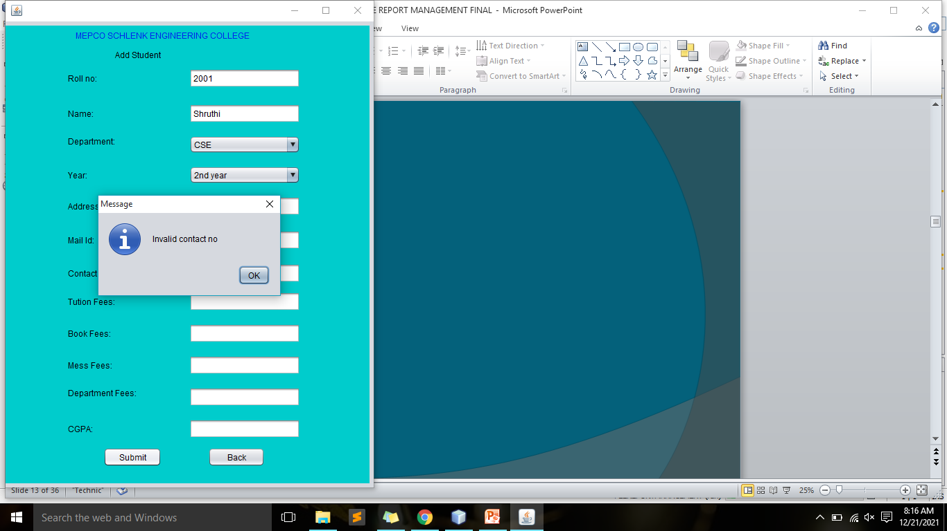

**MISSING OUT A FIELD:**

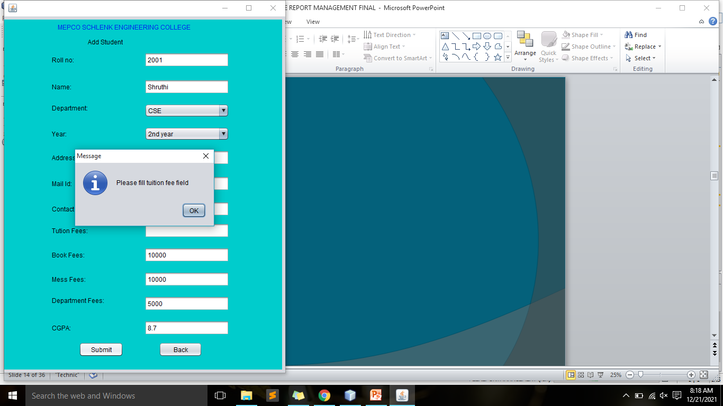

**ADD STUDENT:**

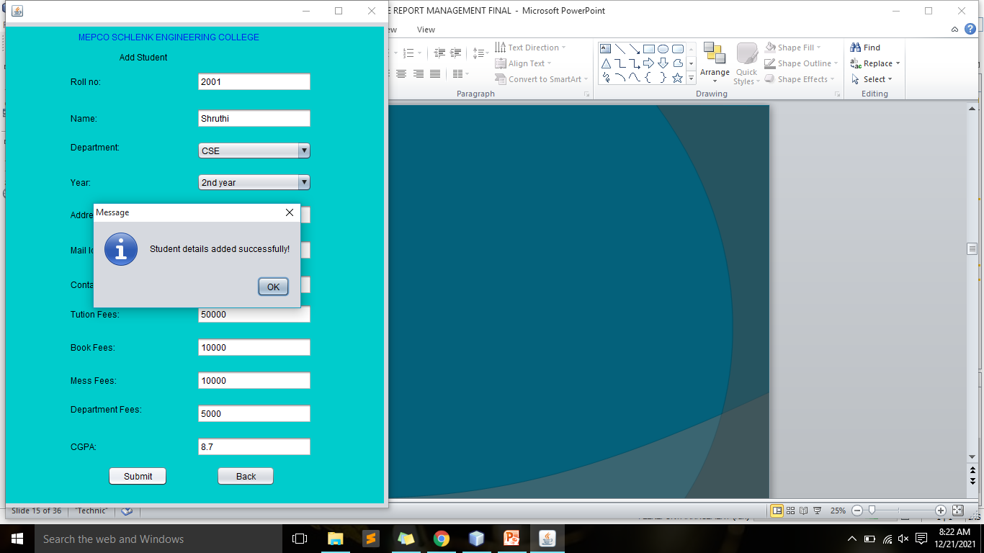

**UPDATE STUDENT:**

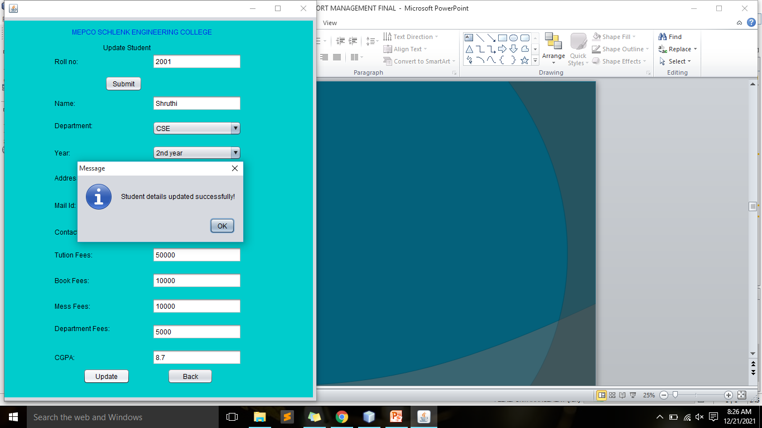

**DELETE STUDENT:**

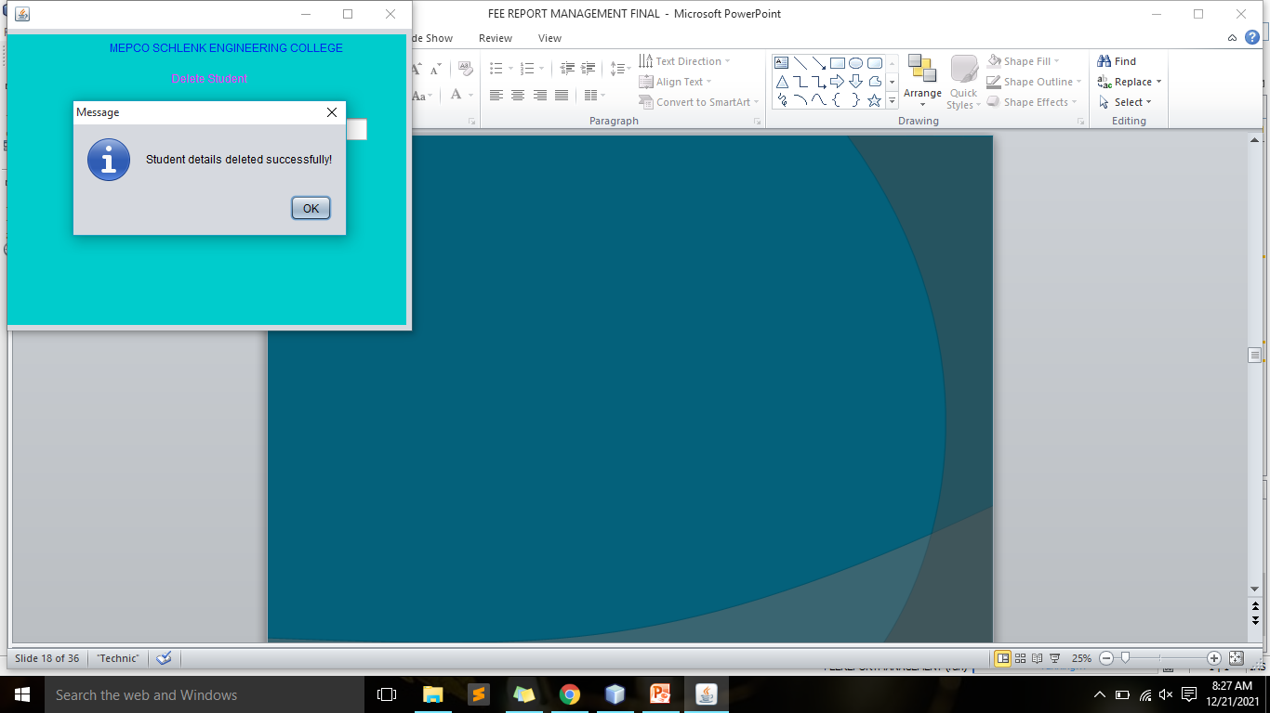

**ADD FEES:**

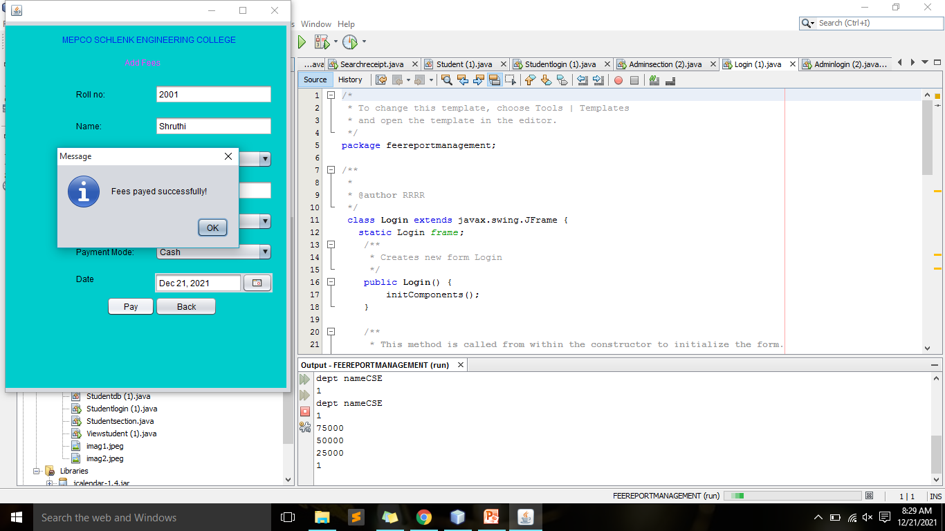

**UPDATE FEES:**

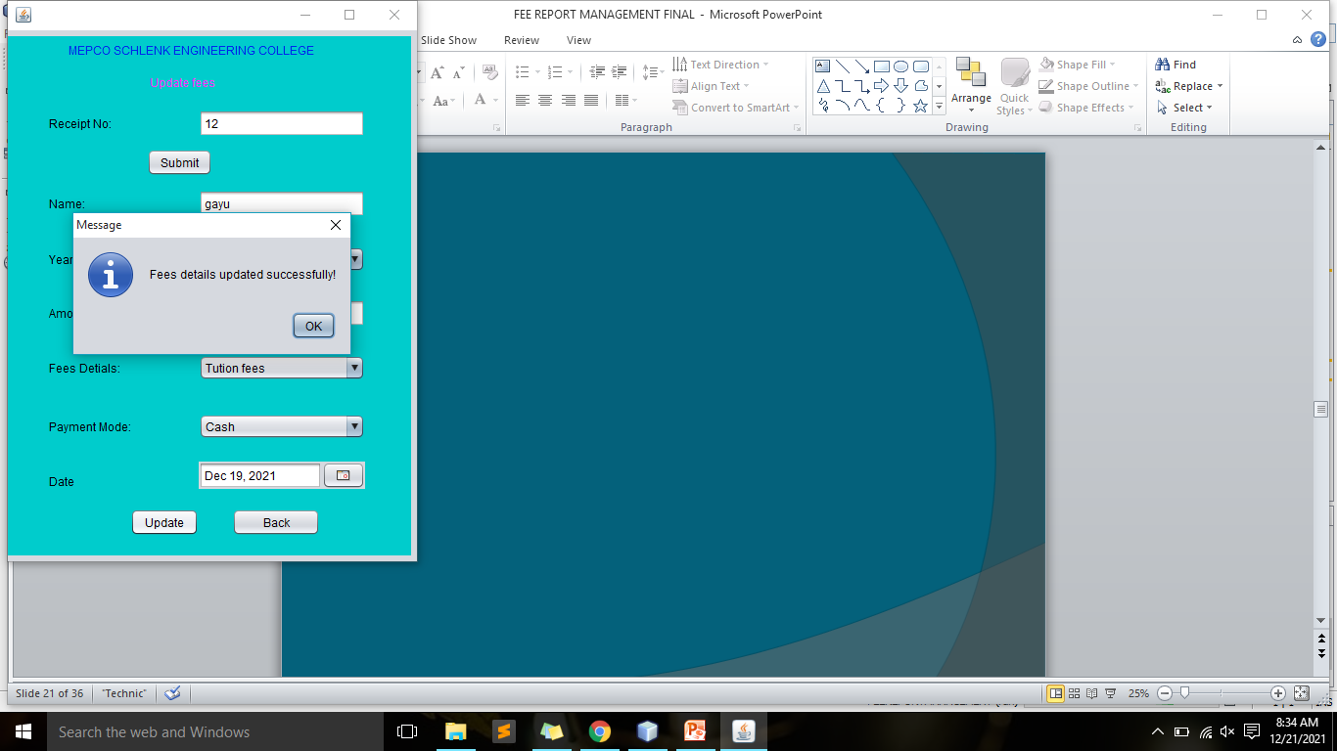

**DELETE FEES:**

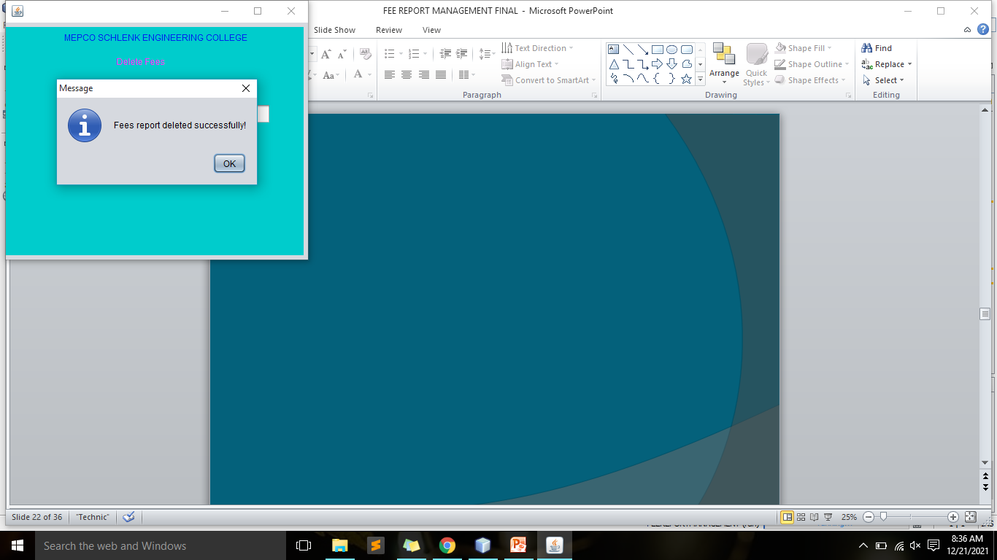

**SEARCH STUDENT BY ROLL NO:**

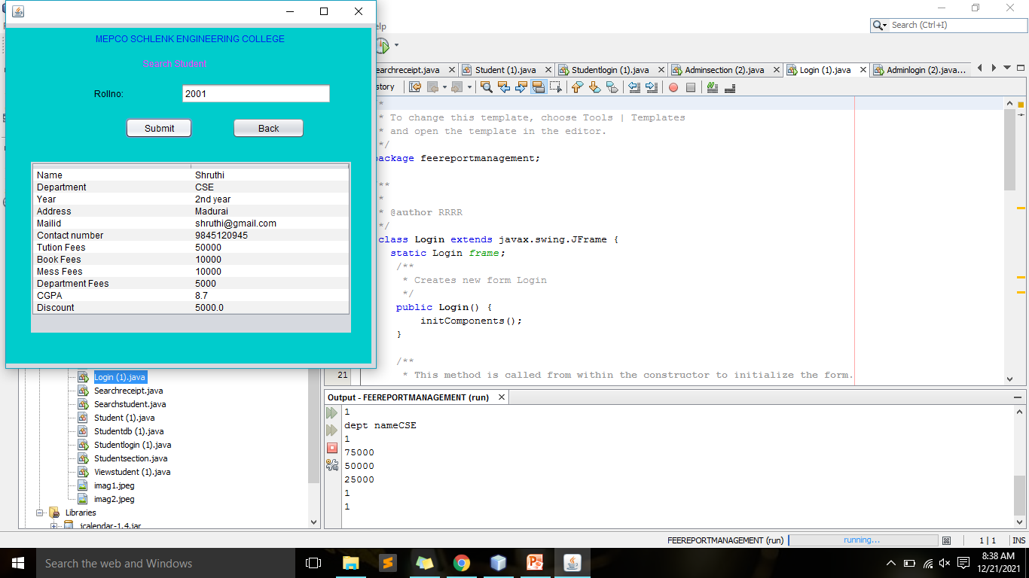

**SEARCH RECEIPT BY RECEIPT NO:**

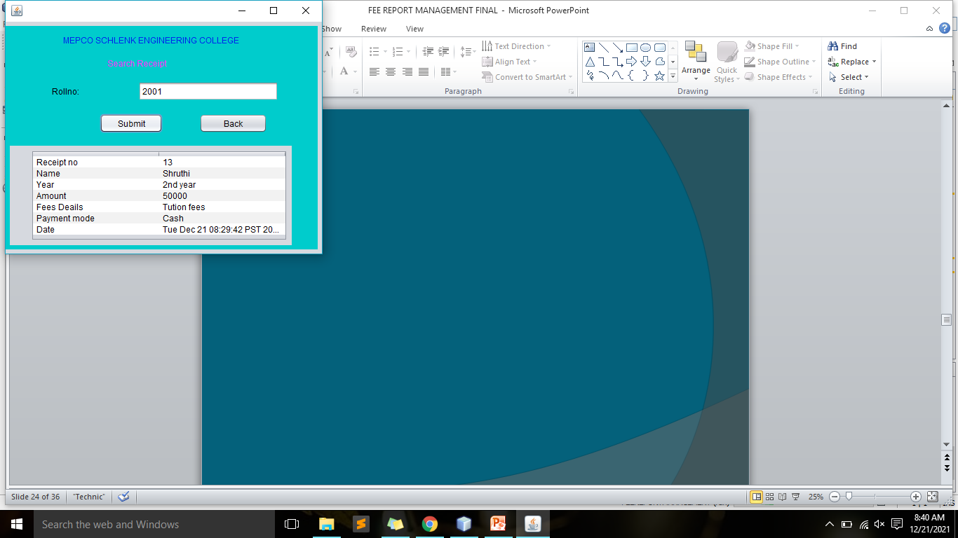

**PAID FEE DETAILS OF STUDENTS:**

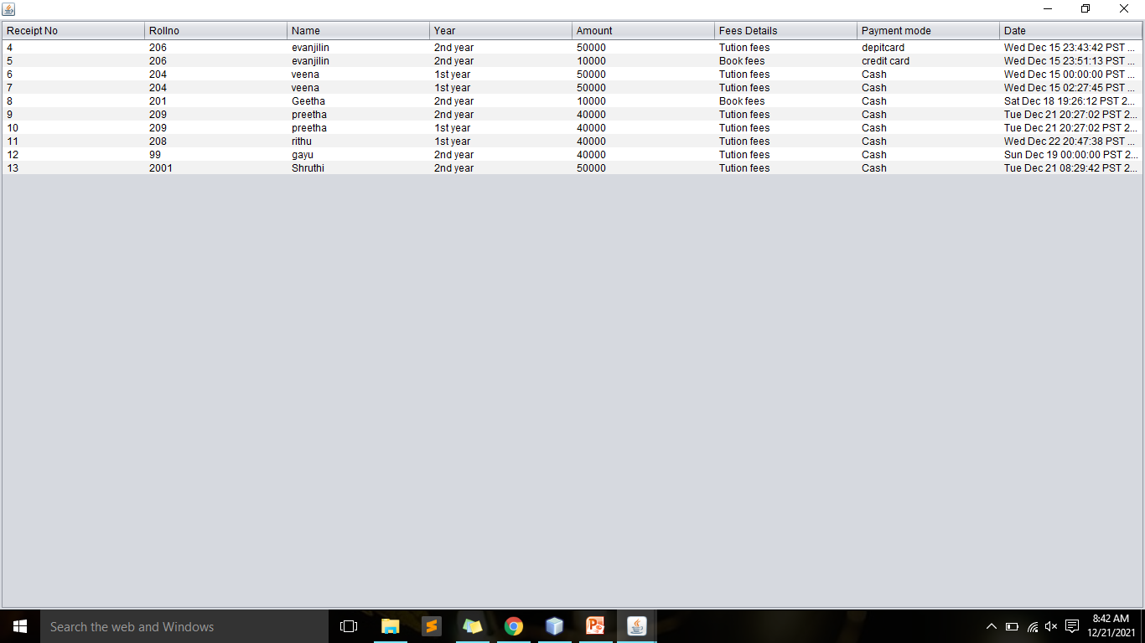

**SEARCH BY DATE:**

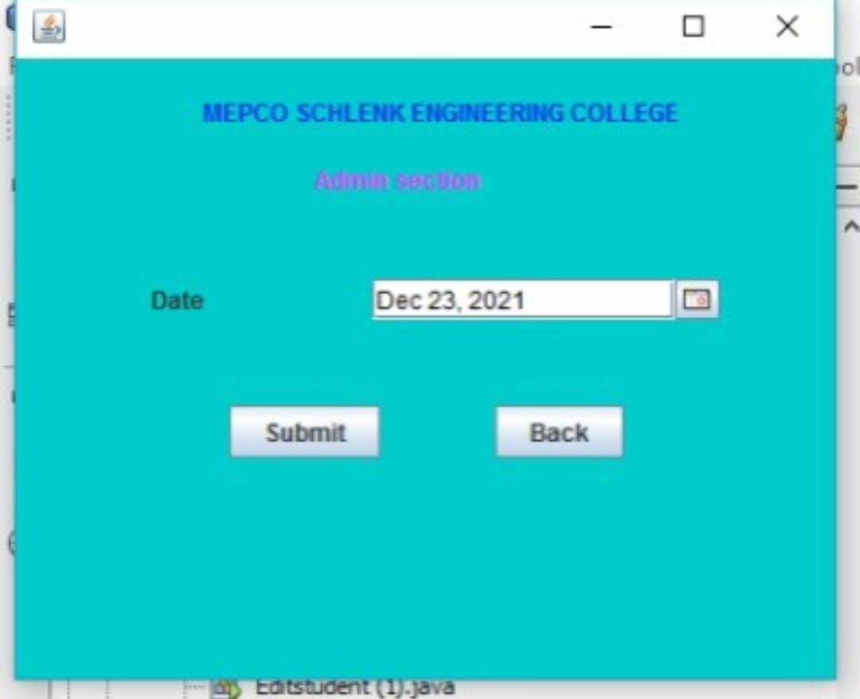

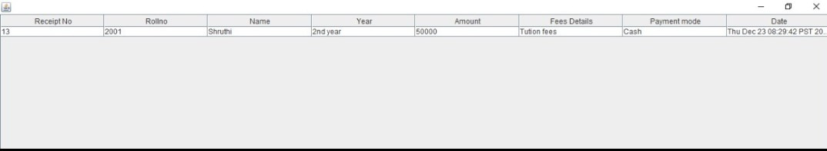

**INVALID SEARCH BY DATE:**

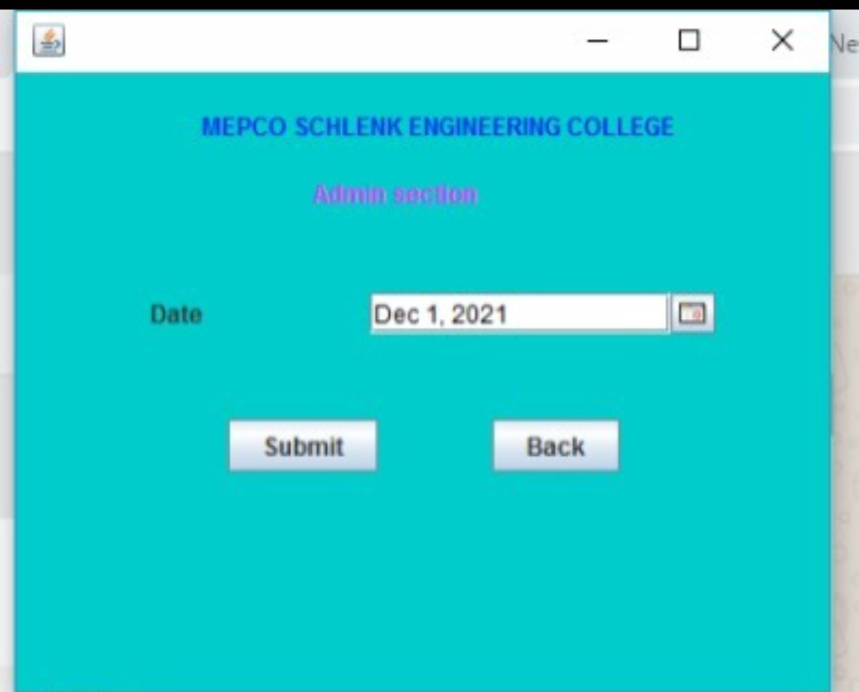

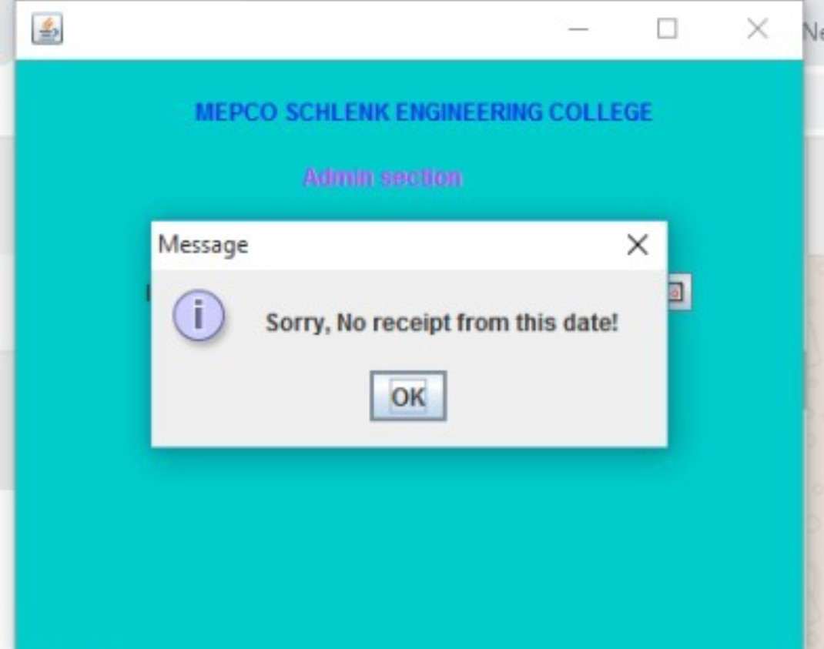

**STUDENT LOGIN:**

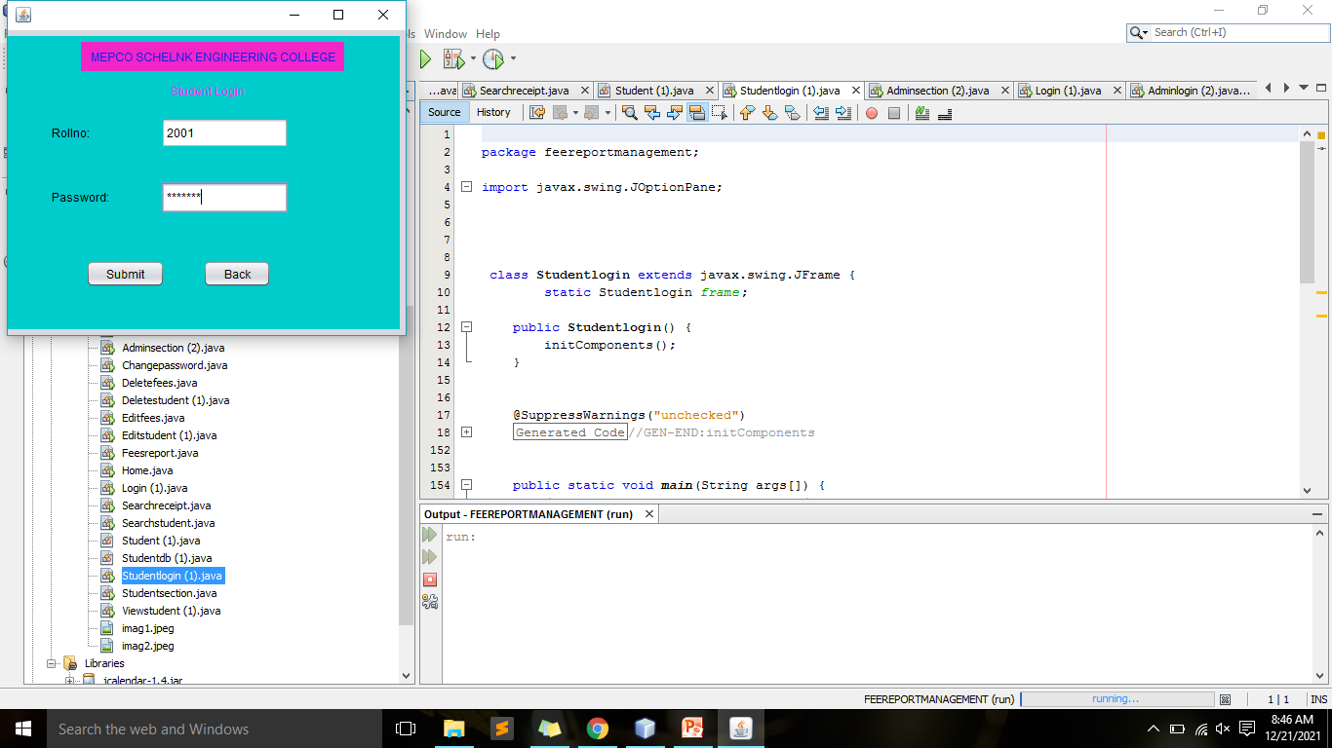

**STUDENT SECTION:**

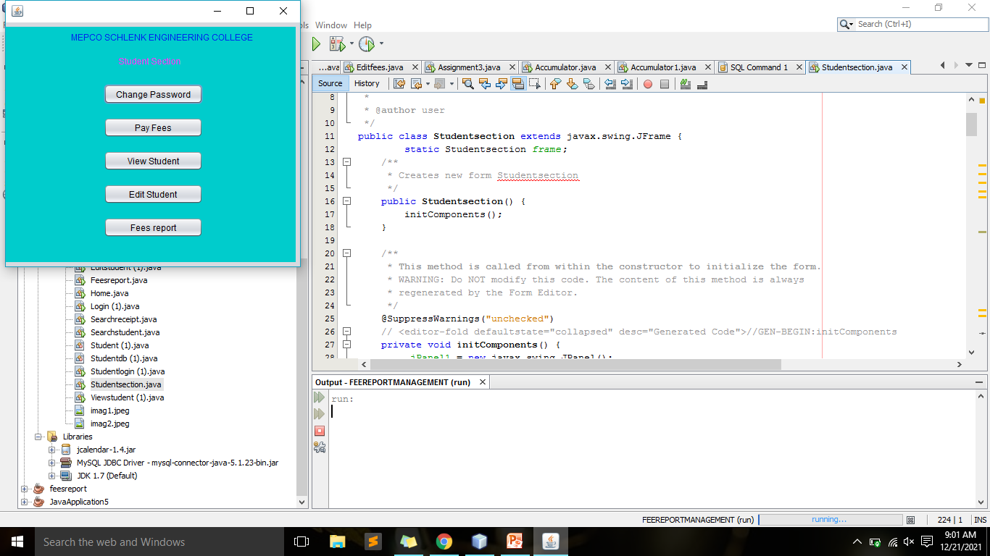

**CHANGE PASSWORD:**

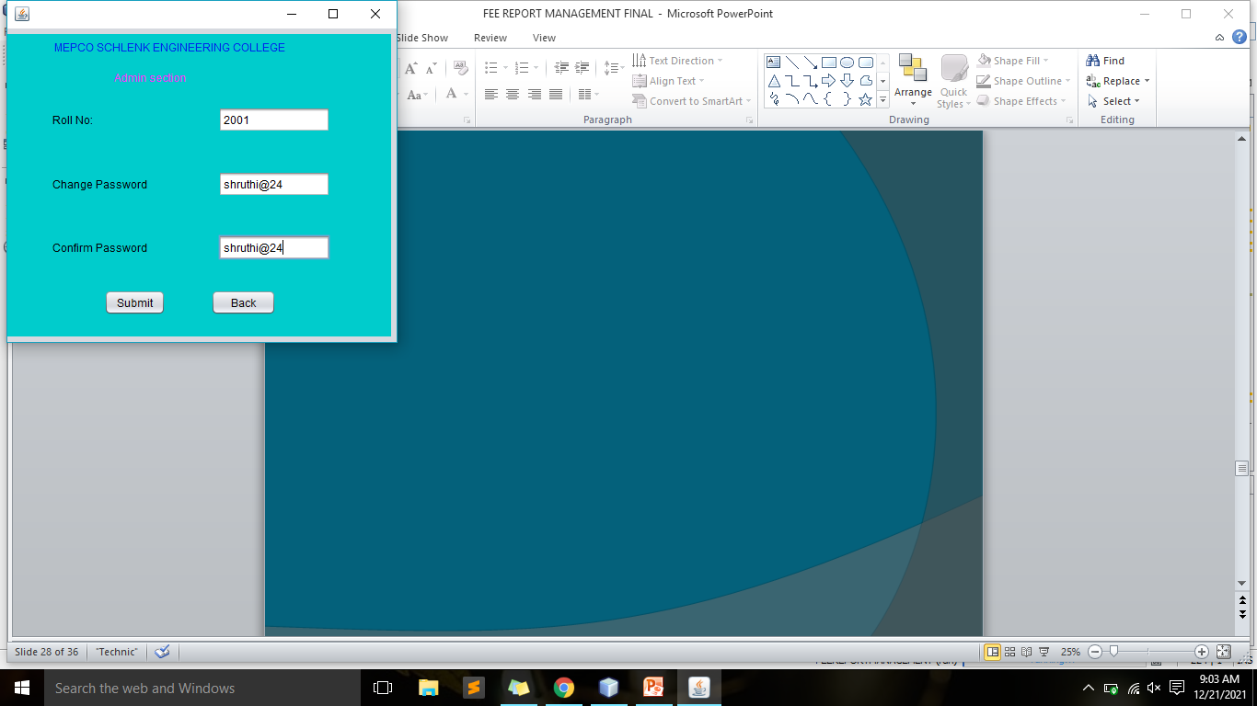

**FEES PAYMENT:**

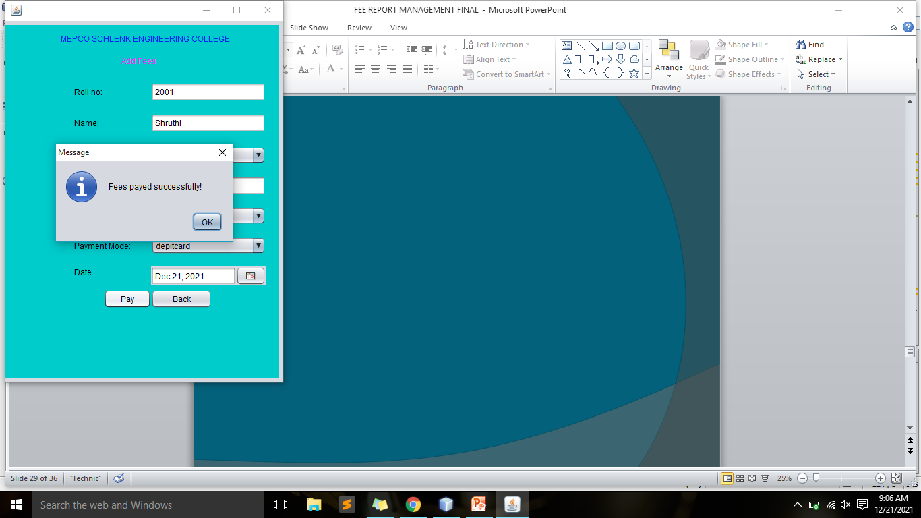

**VIEW STUDENT:**

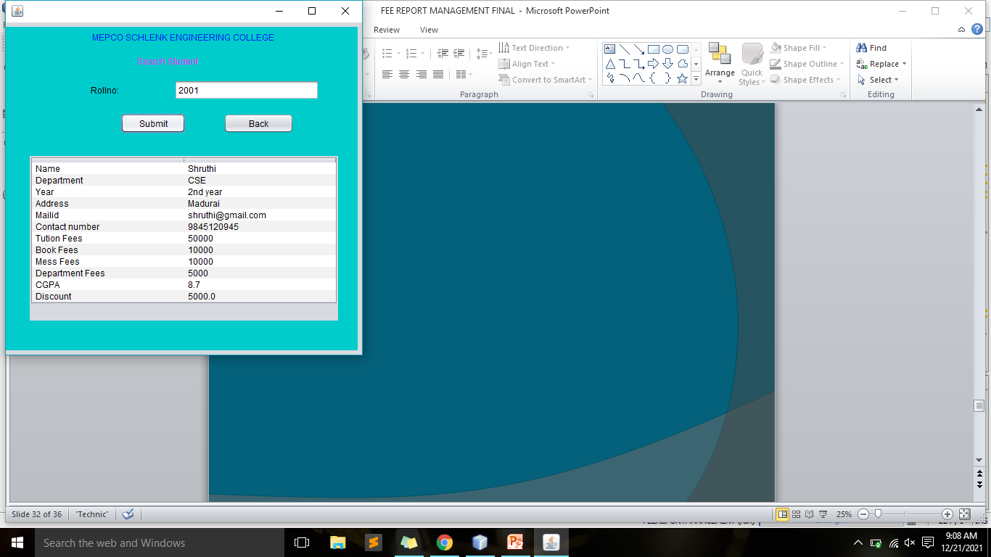

**UPDATE THEIR DETAILS:**

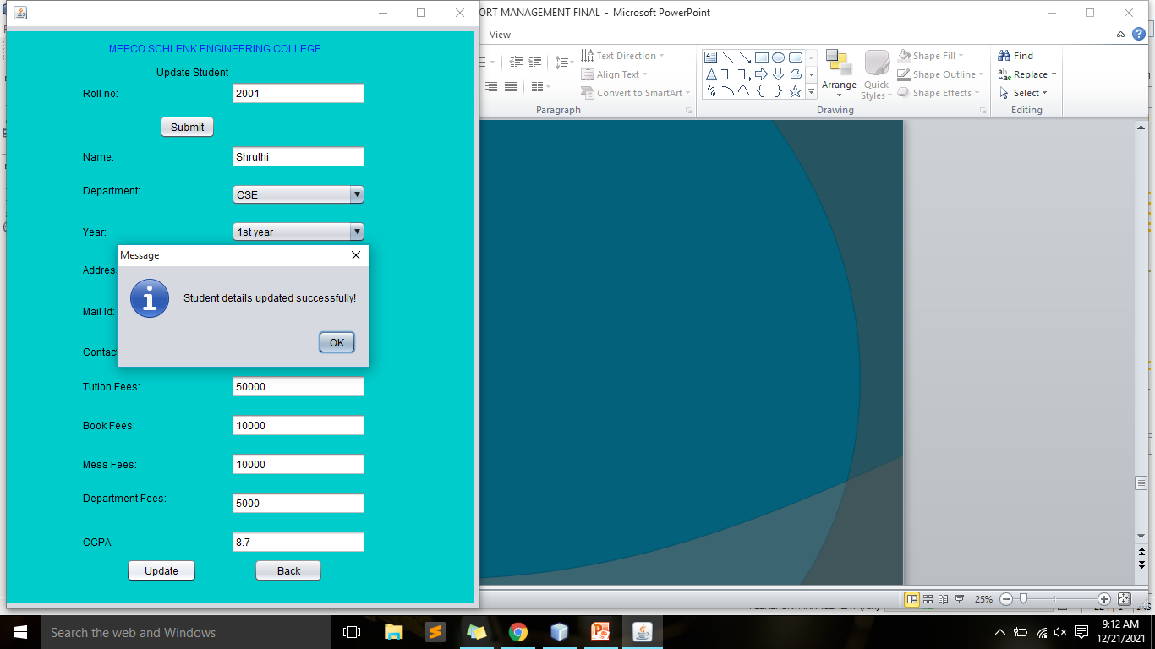

**FEE REPORT:**

